**MINISTRY OF EDUCATION AND TRAINING**

**FPT UNIVERSITY**

Capstone Project Document

The Traffic Sign Recognition and Training

|  |  |
| --- | --- |
| **Group 1** | |
| **Group member** | Mai Văn Tân – Team Leader – SE90061  Bùi Việt Phong – Team Member - SE60747  Hồ Đắc Nghĩa – Team Member - SE60628  Trần Lê Tuấn – Team Member - 60350 |
| **Supervisor** | Mr. Kiều Trọng Khánh |
| **Ext. Supervisor** | N/A |
| **Capstone Project code** | TSRT |

-Ho Chi Minh City, 01/2014-

*This page is intentionally left blank*

***ACKNOWLEDGEMENTS***

# Table of Contents

Table of Contents 4

List of Tables 5

List of Figures 6

Definitions, Acronyms, and Abbreviations 8

A. Software User’s Manual 9

1. Installation Guide 9

1.1 Setting up environment at server site 9

1.2 Deployment at server side 9

1.3 Setting up the environment at client side 11

2. User Guide 13

2.1 Login 13

2.2 Admin 13

2.3 Staff 14

2.4 User – Mobile 20

2.5 User - Website 27

3. User Notice 33

3.1 Image Data Notice 33

3.2 Take image to search 35

# List of Tables

Table 1: Login Step 13

Table 2: Set staff 14

Table 3: Login Step 20

Table 4: Register Step 21

Table 5: Search auto step 21

Table 6: Search auto result step 22

Table 7: Search manual step 23

Table 8: Search manual result Step 24

Table 9: View traffic detail step 25

Table 10: View favorite step 25

Table 11: View history step 26

Table 12: Send report step 26

Table 13: Setting step 27

Table 14: Search auto step 27

Table 15: Search manual step 28

Table 16: View favorite step 29

Table 17: View list history step 30

Table 18: View history detail step 31

Table 19: View traffic sign detail step 32

Table 20: Send report step 33

# List of Figures

Figure 1: Prepare deployment package 9

Figure 2: Deploy database 9

Figure 3: Run tomcat server 9

Figure 4: Copy war file to tomcat server 9

Figure 5: Set console application path 9

Figure 6: Restart tomcat 10

Figure 7: Change Settings 10

Figure 8: Install App 11

Figure 9: Login Page 12

Figure 10: Account Manage Page 13

Figure 11: Traffic Sign Manage Page 14

Figure 12: Add New Traffic Sign Modal 15

Figure 13: Report Manage Page 16

Figure 14: Report Detail Modal 17

Figure 15: Edit Wrong Recognition Page 18

Figure 16: Login Screen 19

Figure 17: Register Screen 20

Figure 18: Search Auto Screen 20

Figure 19: Search auto result screen 21

Figure 20: Search manual Screen 22

Figure 21: Search manual result Screen 23

Figure 22: View traffic detail screen 24

Figure 23: View favorite screen 24

Figure 24: View history screen 25

Figure 25: Send report screen 25

Figure 26: Setting screen 26

Figure 27: Search auto page 26

Figure 28: Search manual page 27

Figure 29: Favorite page 28

Figure 30: History page 29

Figure 31: History detail page 30

Figure 32: Traffic sign detail popup 31

Figure 33: Send report popup 32

# Definitions, Acronyms, and Abbreviations

|  |  |
| --- | --- |
| TSRT | Traffic Sign Recognition and Training |
| TS | Traffic sign |

# Software User’s Manual

## Installation Guide

### Setting up environment at server site

The following software must be installed into the server machine:

#### Hardware requirements

VPS server to run the web and service

* CPU 1 Core 2.0GHz.
* 512MB of RAM.
* 20GB of hard disk.

A personal computer to access VPS server:

* CPU Core i3 2.0 GHz
* 4GB of Ram
* 300GB of hard disk

#### Software requirements

Software to run in VPS server:

* Java environment: Java 1.7.0_51
* Web Server: Tomcat 7.0
* Operation system: Linux 13.10
* Database management: Mysql 5.20
* Other library:
* OpenCV 2.4.8
* Jsoncpp 0.5.0

Software to run in personal computer to process the deployment:

* SSH Client to access VPS server
* FTP Client to upload file to VPS server

In this guide we can use Firefox with FireSSH and FireFTP addon.

#### Mobile Requirement

* Android 4.0
* Camera 5.0 Megapixel or above

### Deployment at server side

#### Prepare deployment package

* From personal computer access to VPS using FireFTP and FireSSH
* Upload deployment package to a folder on server, for example /home/deploy/deployment.zip
* Extract the deployment.zip
* Run the install.sh script to install the requirement software and library (this may take about 2h depend on your VPS internet connection). Flow the guide of script to complete the installation.
* Reboot VPS



**Figure 1: Prepare deployment package**

#### Deploy database

* Using SSH client, extract DB.sql script by command: mysql –u root –p
* Enter your mysql root password
* Then run command: DB.sql;

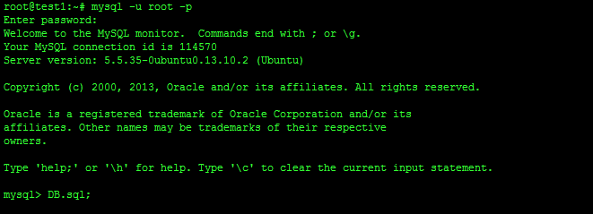**Figure 2: Deploy database**

#### Deploy web application on server

* Run tomcat server by script: startup.sh

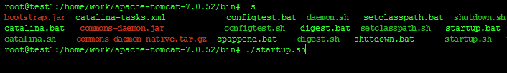

**Figure 3: Run tomcat server**

* Copy 2 War file TrafficService.war, TrafficWeb.war to webapps folder of tomcat and wait to tomcat auto deploy the war file.



**Figure 4: Copy war file to tomcat server**

* Final edit the console app path in config.properties file and restart tomcat server.



**Figure 5: Set console application path**

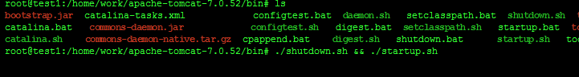

**Figure 6: Restart tomcat**

### Setting up the environment at client side

#### Setting up for computer

* The client devices need to have one of the following browsers to access the website:
* Google Chrome.
* Firefox.

#### Setting up for Android devices

* Change setting to install unknown source apk.

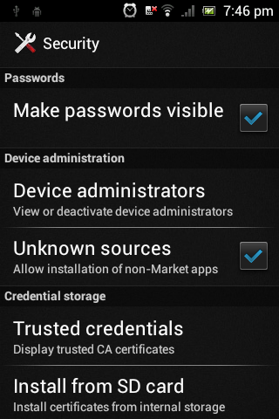

**Figure 7: Change Settings**

* Use browser and goto address 192.168.218.1:2987, download the apk file.
* Click Install to install the app.

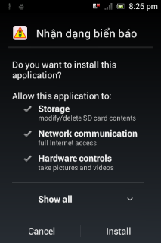 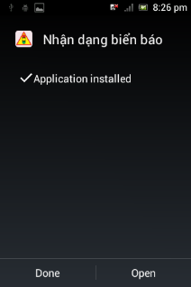

**Figure 8: Install App**

## User Guide

The user guide is based on the normal workflow of the system

### Login

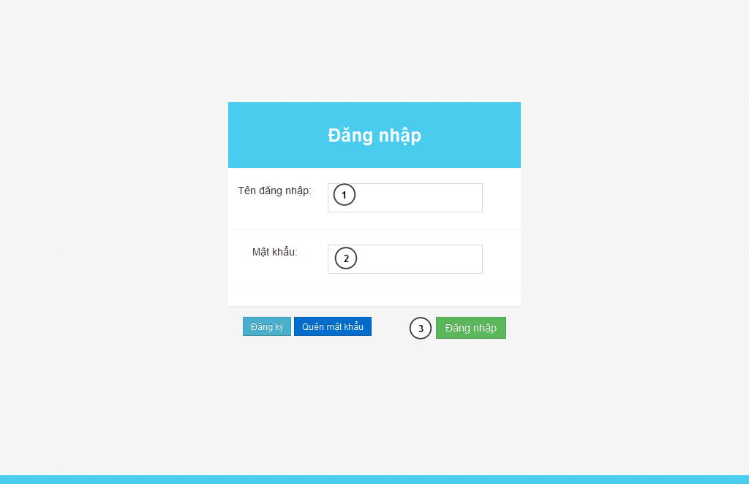

**Figure 9: Login Page**

|  |  |
| --- | --- |
| **Step** | **Description** |
| 1 | Fill UserID to “Tên đăng nhập” textbox |
| 2 | File password to “Mật khẩu” textbox |
| 3 | Press “Đăng nhập” button to login. |

**Table 1: Login Step**

### Admin

#### Set staff

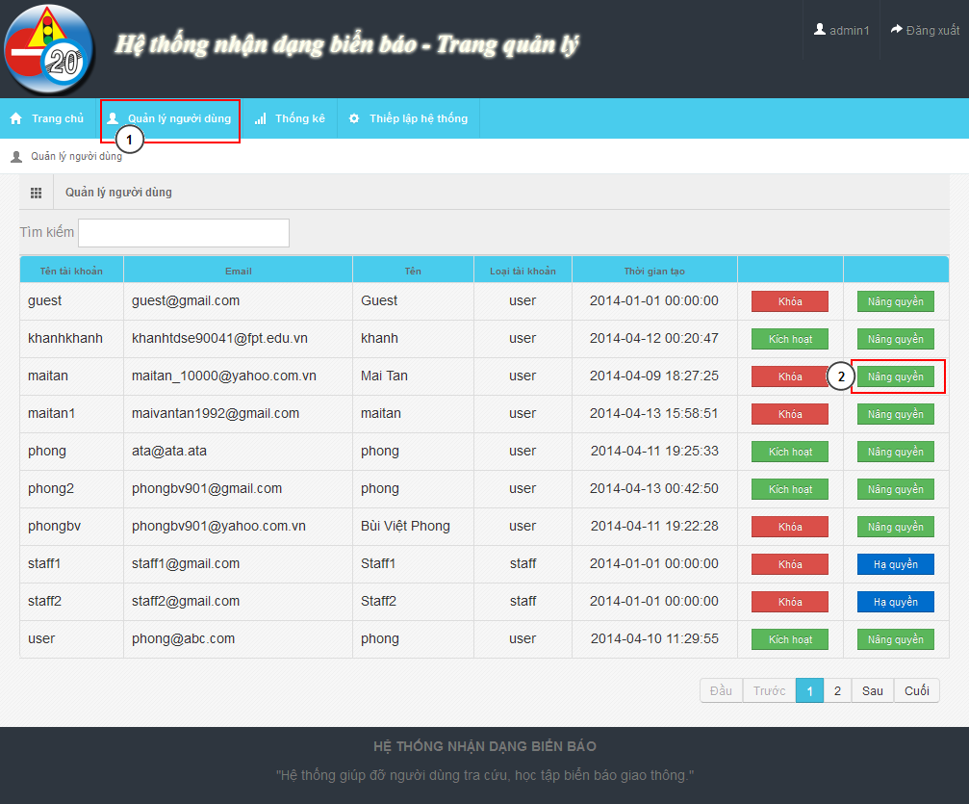

**Figure 10: Account Manage Page**

|  |  |
| --- | --- |
| **Step** | **Description** |
| 1 | “Quản lý người dùng” menu |
| 2 | Find user want to set staff. Click “Nâng quyền” |

**Table 2: Set staff**

### Staff

#### Add new traffic sign

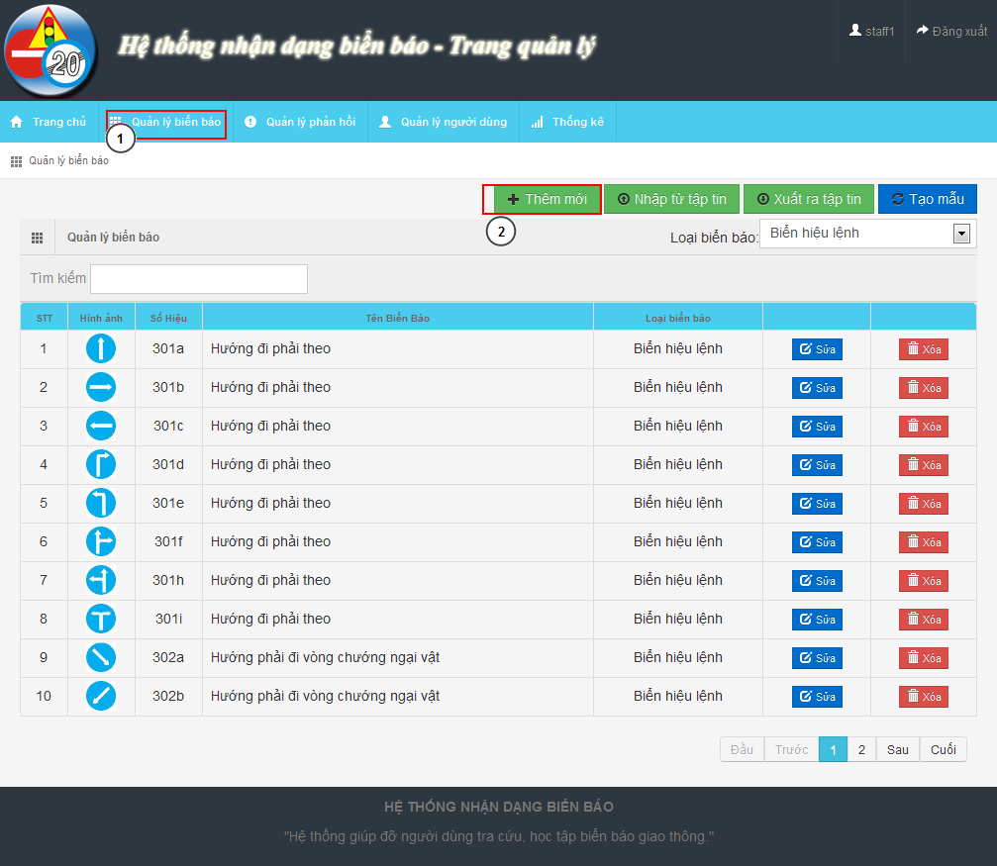

**Figure 11: Traffic Sign Manage Page**

|  |  |
| --- | --- |
| **Step** | **Description** |
| 1 | “Quản lý biển báo” menu |
| 2 | Click on “Thêm mới” button to show Add new modal |

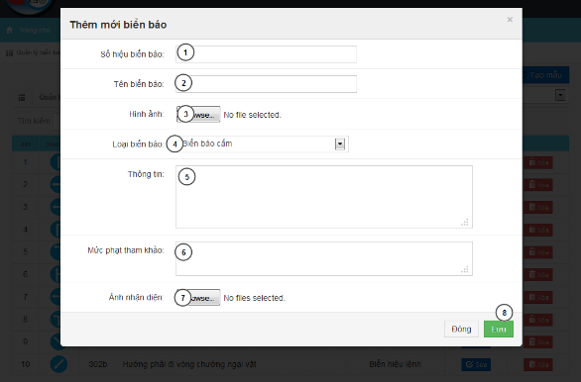

**Figure 12: Add New Traffic Sign Modal**

|  |  |
| --- | --- |
| **Step** | **Description** |
| 1 | Input traffic sign label |
| 2 | Input traffic name |
| 3 | Input traffic image |
| 4 | Select traffic type |
| 5 | Input traffic sign information |
| 6 | Input traffic sign penalty fee |
| 7 | Input train image for traffic sign |
| 8 | Press “Lưu” button to save traffic sign |

#### Fix wrong recognition from report

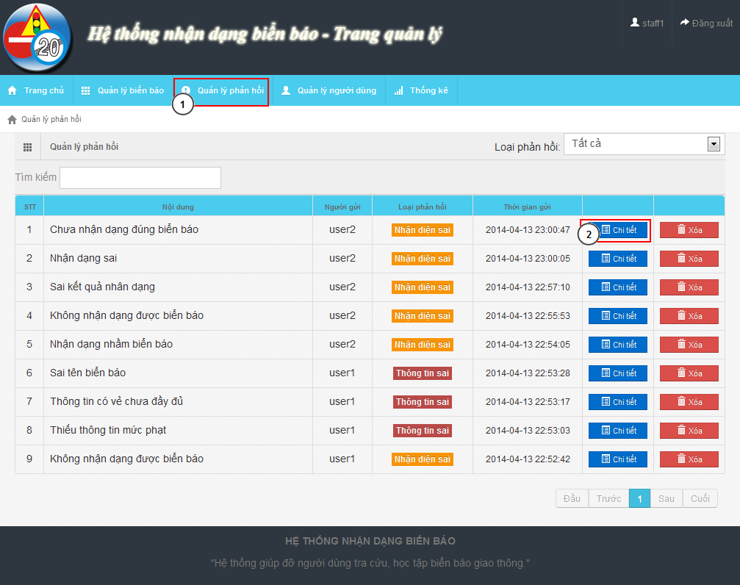

**Figure 13: Report Manage Page**

|  |  |
| --- | --- |
| **Step** | **Description** |
| 1 | “Quản lý phản hồi” menu |
| 2 | Find the report and click “Chi tiết” to show detail of report |

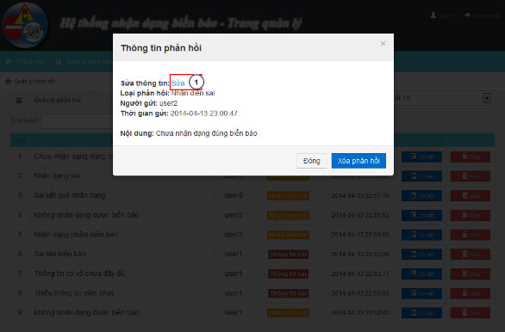

**Figure 14: Report Detail Modal**

|  |  |
| --- | --- |
| **Step** | **Description** |
| 1 | Click “Sửa” to edit the result |

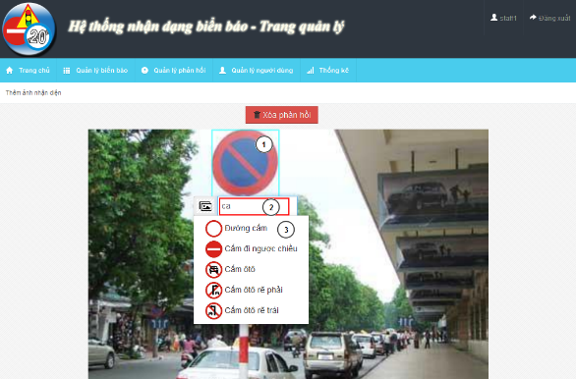

**Figure 15: Edit Wrong Recognition Page**

|  |  |
| --- | --- |
| **Step** | **Description** |
| 1 | Move mouse to the detected area |
| 2 | Input text to find the right traffic sign name |
| 3 | Select traffic sign name match with the image |

### User – Mobile

#### C:\Users\phongbv\Desktop\Do an\screen chot\login.pngLogin

**Figure 16: Login Screen**

|  |  |
| --- | --- |
| **Step** | **Description** |
| 1 | Fill Username. Example: phongbv |
| 2 | Fill Password. Example: 123456 |
| 3 | Click “Đăng nhập” button |

**Table 3: Login Step**

#### Register

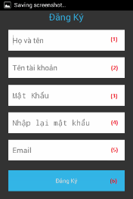

**Figure 17: Register Screen**

|  |  |
| --- | --- |
| **Step** | **Description** |
| 1 | Fill fullname. Example: Bùi Việt Phong |
| 2 | Fill account name. Example: phongbv |
| 3,4 | Fill password. Example: 123456 |
| 5 | Fill email. Format email: abc@example.com |
| 6 | Press “Đăng ký” button |

**Table 4: Register Step**

#### Search Auto

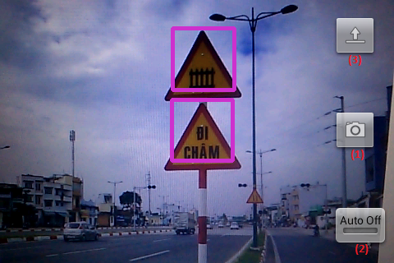

**Figure 18: Search Auto Screen**

|  |  |
| --- | --- |
| **Step** | **Description** |
| 1 | Press button to take picture and wait for result. |
| 2 | Click button switch on or off auto take picture mode. |
| 3 | Press button to select picture from mobile instead of take a picture by camera. |

**Table 5: Search auto step**

#### Search auto result

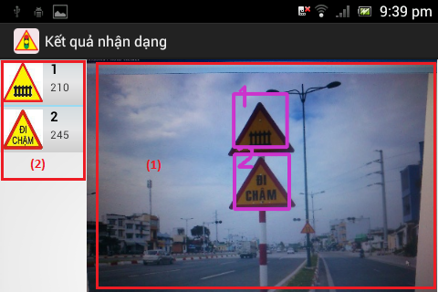

**Figure 19: Search auto result screen**

|  |  |
| --- | --- |
| **Step** | **Description** |
| 1 | Picture was taken by user before. |
| 2 | List result, position match with number in the image. Select one item to view traffic sign detail |

**Table 6: Search auto result step**

#### Search manual

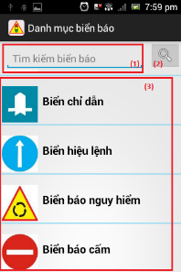

**Figure 20: Search manual Screen**

|  |  |
| --- | --- |
| **Step** | **Description** |
| 1 | Fill search key. Example: “đường cấm”. |
| 2 | Click button to search by traffic sign’s name. |
| 3 | Select one category to view list traffic sign by category. |

**Table 7: Search manual step**

#### C:\Users\phongbv\Desktop\Do an\screen shot\list traffic.pngSearch manual result

**Figure 21: Search manual result Screen**

|  |  |
| --- | --- |
| **Step** | **Description** |
| 1 | Select one traffic sign to view detail. |

**Table 8: Search manual result Step**

#### View traffic detail

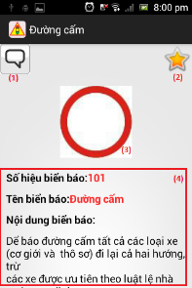

**Figure 22: View traffic detail screen**

|  |  |
| --- | --- |
| **Step** | **Description** |
| 1 | Press this button to report wrong information |
| 2 | Press this button to add or remove traffic sign to favorite |
| 3 | Traffic sign’s image |
| 4 | Traffic sign’s information |

**Table 9: View traffic detail step**

#### C:\Users\phongbv\Desktop\Do an\screen shot\favorite.pngView favorite

**Figure 23: View favorite screen**

|  |  |
| --- | --- |
| **Step** | **Description** |
| 1 | Select one traffic sign to view detail. (Or hold for 1 second, then select “Xóa” to delelte traffic sign from favorite list) |

**Table 10: View favorite step**

#### View history

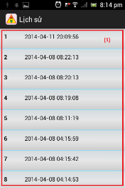

**Figure 24: View history screen**

|  |  |
| --- | --- |
| **Step** | **Description** |
| 1 | Select one row to view search auto result detail. (Or hold for 1 second, then select “Xóa” to delelte result from history list) |

**Table 11: View history step**

#### C:\Users\phongbv\Desktop\Do an\screen shot\feedback.pngSend Report

**Figure 25: Send report screen**

|  |  |
| --- | --- |
| **Step** | **Description** |
| 1 | Enter report content. |
| 2 | Press this button to send report |

**Table 12: Send report step**

#### Setting

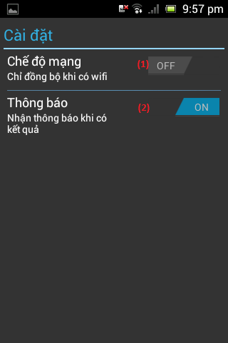

**Figure 26: Setting screen**

|  |  |
| --- | --- |
| **Step** | **Description** |
| 1 | Press this button to turn on or off “synchronize when on wifi only” mode. |
| 2 | Press this button to turn on or off notification when have search auto result. |

**Table 13: Setting step**

### User - Website

#### Search auto

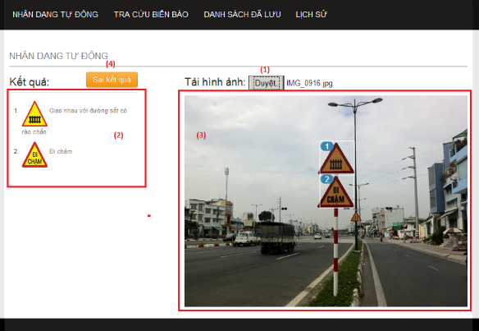

**Figure 27: Search auto page**

|  |  |
| --- | --- |
| **Step** | **Description** |
| 1 | Click button “Chọn tệp tin” to select image for upload and wait for a few seconds. |
| 2 | List result, position match with number in the image. Select one item to view traffic sign detail |
| 3 | Picture was uploaded by user before |
| 4 | Click button “Sai kết quả” to report if the result is wrong. |

**Table 14: Search auto step**

#### Search manual

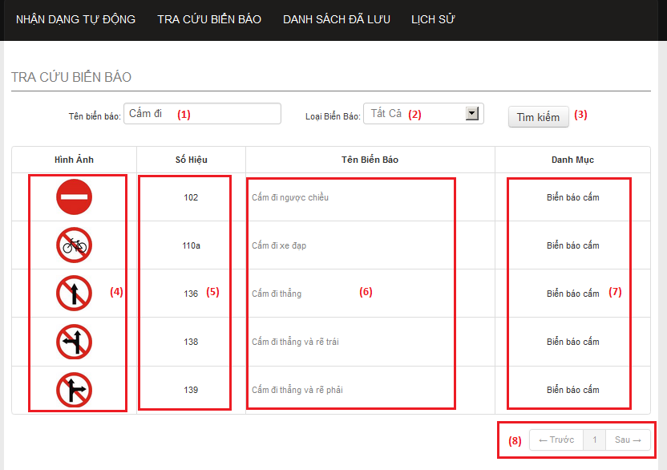

**Figure 28: Search manual page**

|  |  |
| --- | --- |
| **Step** | **Description** |
| 1 | Enter traffic sign’s name. Example: “cấm đi”. |
| 2 | Select one item to choose traffic sign category. |
| 3 | Click button “Tìm kiếm” to search traffic sign. |
| 4 | This column display traffic signs’ image. Click image to view traffic sign detail. |
| 5 | This column display traffic signs’ ID number. |
| 6 | This column display traffic signs’ name. Click traffic sign’s name to view traffic sign detail. |
| 7 | This column display traffic signs’ category. |
| 8 | Select number or “Trước”, “Sau” to view others records in the table. |

**Table 15: Search manual step**

#### View list favorite

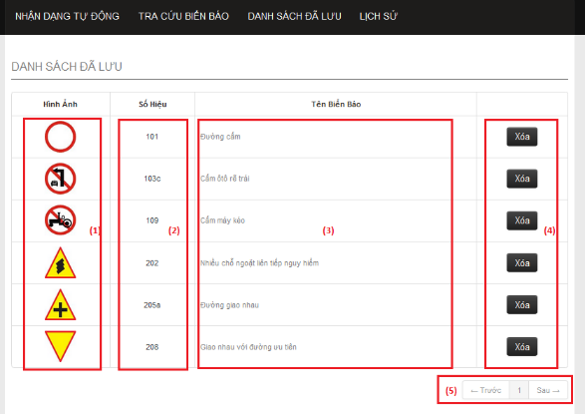

**Figure 29: Favorite page**

|  |  |
| --- | --- |
| **Step** | **Description** |
| 1 | This column display traffic signs’ image. Click image to view traffic sign detail. |
| 2 | This column display traffic signs’ ID number. |
| 3 | This column display traffic signs’ name. Click traffic sign’s name to view traffic sign detail. |
| 4 | Click button “Xóa” to remove one traffic sign from favorite list. |
| 5 | Select number or “Trước”, “Sau” to view others records in the table. |

**Table 16: View favorite step**

#### View list history

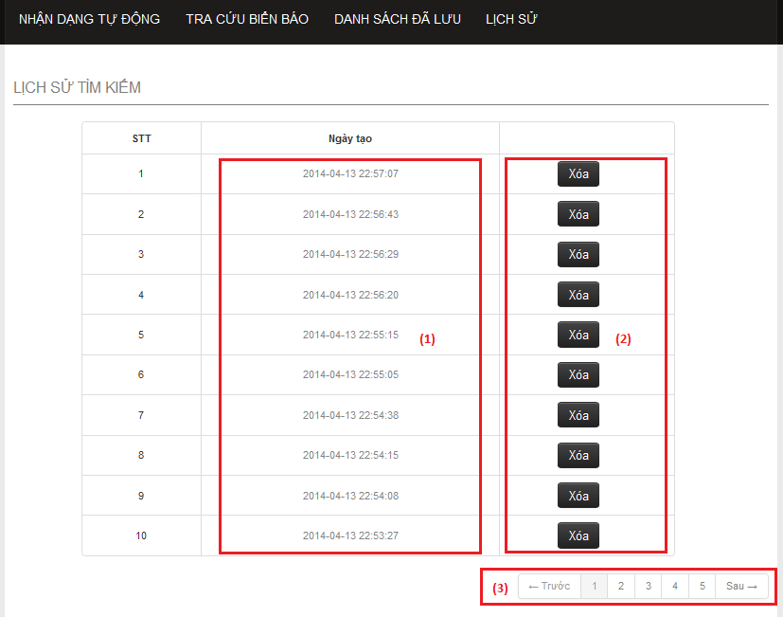

**Figure 30: History page**

|  |  |
| --- | --- |
| **Step** | **Description** |
| 1 | This column display the times when the history was created. Click link to view history detail. |
| 2 | Click button “Xóa” to remove one history from history list. |
| 3 | Select number or “Trước”, “Sau” to view others records in the table. |

**Table 17: View list history step**

#### View history detail

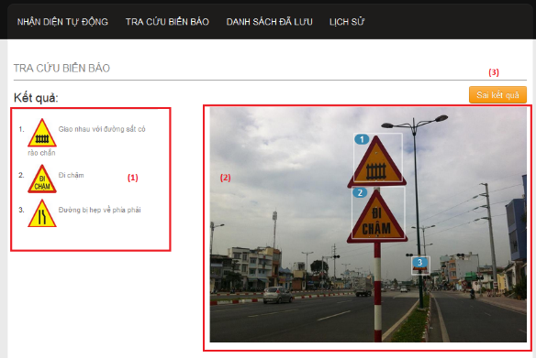

**Figure 31: History detail page**

|  |  |
| --- | --- |
| **Step** | **Description** |
| 1 | List result, position match with number in the image. Select one item to view traffic sign detail |
| 2 | Picture was uploaded by user before |
| 3 | Click button “Sai kết quả” to report if the result is wrong. |

**Table 18: View history detail step**

#### View traffic sign detail

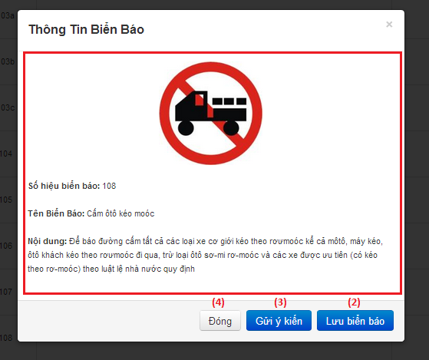

**Figure 32: Traffic sign detail popup**

|  |  |
| --- | --- |
| **Step** | **Description** |
| 1 | Traffic sign’s detail information. |
| 2 | Click “Lưu biển báo” to add traffic sign to favorite list. |
| 3 | Click button “Gửi ý kiến” to report if the information is wrong. |
| 4 | Click button “Đóng” to close popup. |

**Table 19: View traffic sign detail step**

#### Send report

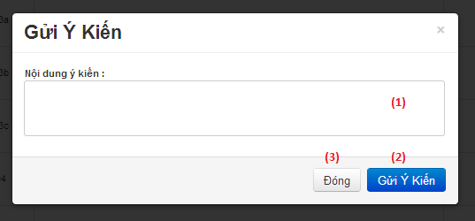

**Figure 33: Send report popup**

|  |  |
| --- | --- |
| **Step** | **Description** |
| 1 | Enter report content. |
| 2 | Click button “Gửi ý kiến” to send report. |
| 3 | Click button “Đóng” to close popup. |

**Table 20: Send report step**

## User Notice

### Image Data Notice

* Each traffic sign should have at least 5 images for train image.
* The image should be in good condition, not have too much noise, or hide by another object.

Example of good image data:



Sample data of a traffic sign about 5-10 images:

* 60% taken from front of traffic sign.
* 40% taken from to side of traffic sign about 30 degrees side long.

Example of a good sample data set:



Avoid using not clear images like these:

### Take image to search

The below is recommend for the best image when search auto:

* Position and angle:
* The size of traffic sign in image:

By default the best size of traffic image is from 1/10 to ¼ the width of image.

